**Symbiosis Skills and Professional University Kiwale, Pune**

------------------------------------------------------------------------------------------

**PROJECT REPORT**

**On**

**“Netflix Data Visualization”**

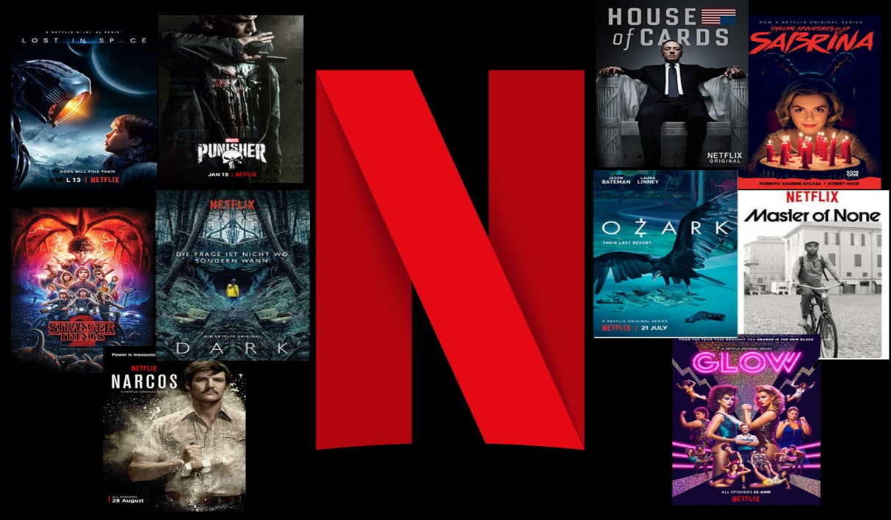

**Submitted by**

**Mr. Gaurav Pramod Kondvilkar**

**(Registration Number: 2001207072)**

**DA-Batch-II**

**Under The Guidance of**

**Trainer's Name: Mr. Kushal Sharma**

**STUDENT DECLARATION AND ATTESTATION BY TRAINER**

This is to declare that this report has been written by me. No part of the report is plagiarized from other sources. All information included from other sources have been duly acknowledged. I aver that if any part of the report is found to be plagiarized, I shall take full responsibility for it.

Signature of student

**Name of student: Mr. Gaurav Pramod Kondvilkar**

Registration Number: 2001207072

Signature of trainer

**Name of trainer: Mr. Kushal Sharma**

**CERTIFICATE**

This is to certify that the report entitled, “**Netflix Data Visualization**” submitted by ”Mr. Gaurav Pramod Kondvilkar” to Symbiosis Skills and Professional University, Pune, Maharashtra, India, is a record of bonafide Project work carried out by him under my supervision and guidance and is worthy of consideration for the completion of certificate course in ‘Data Associate”.

Signature of Trainer

Name of Trainer : Kushal Sharma

Date: / / 2021

__________________ __________________

Supervisor Supervisor

**ACKNOWLEDGEMENTS**

This is to acknowledge all those without whom this project would not have been reality. Firstly, I would wish to thank our Trainer Mr. Kushal Sharma sir who gave his immense support, dedicated his time towards it and made us understand how to make this project. Without his guidance, the project would not have been complete.

A project is a bridge between theoretical and practical learning and with this thinking I worked on the project and made it successful due to timely support and efforts of all who helped me.

Once again, I would like to put my gratitude and sincere thanks to DR. Shravan Kadvekar for giving me this opportunity. Then I would also like to thank my classmates and my friends also for their encouragement and help in designing and making my project creative. Only because of them I was able to create my project and make it a good and enjoyable experience.

**INDEX (Sample)**

|  |  |  |  |  |
| --- | --- | --- | --- | --- |
|  | | | | |
| **Sl. No** | **Index** |  |  |  |
| 1 | **Acknowledgement** | |  |  |
| 2 | **Purpose And Problem Statement** | |  |  |
|  | 2.1 | Purpose of Project | |  |
|  | 2.2 | Problem Statement | |  |
|  |  |  | |  |
| 3 | **Objective of the Project** | | |  |
|  | 3.1 | General Objective | |  |
|  |  |  | | |
| 4 | **Strategy and Steps Performed** | | |  |
|  | 4.1 | Importing libraries | |  |
|  | 4.2 | Loading and Reading the dataset | |  |
|  | 4.3 | Describe the model | |  |
|  | 4.4 | Finding the missing values | |  |
|  | 4.5 | Comparison of TV Shows and Movies | | |
|  | 4.6 | Movies and TV Shows Content Comparison | | |
|  | 4.7 | Year wise content released visualization | | |
|  |  |  | | |
| 5 | **Data Visualization on tableau & power bi** | | |  |
|  | 5.1 | Tableau Data Representation | | |
|  | 5.2 | Power Bi Data Represation | | |
|  |  |  | | |
| 6 | **Future Scope and Conclusion** | | |  |

**2.**

**PURPOSE AND PROBLEM STATEMENT OF PROJECT**

**Purpose Of Project**

Netflix is one of the largest online streaming media providers. It began its operations in

1997. Founded by two tech entrepreneur Reed Hastings and Marc Randolph. The Company’s

head office is in Los Gatos, California. Netflix’s initially started selling DVDs or provide

them on a rental basis. Over the period with growth of internet users and the decline of DVD

sales and rental services, it changed its business model to video on demand. From 2012

onwards, it started producing its original TV-series and movies. Netflix uses bigdata analytics

to understand its customers base better. By using these data, they provide better service or

product to the customer. Netflix collects huge amounts of data from a vast variety of

subscriber base. It collects data such as the location of a user; content watched by the user,

user interests, the data searched by the user, and the time at which user watched. Based on

these parameters its algorithm gives a personalized recommendation based on the user

interest. Netflix has constantly focused on changing business needs they have moved their

business model from DVD rental to video on demand and currently producing original

shows. In this paper we analyze various business strategies of Netflix. This paper also

analyzes how Netflix with the help of bigdata analytics focused on improving the

subscriber’s experience and how it helped to be more customer-centric and increased its user

base.

**Problem Statement**

For any OTT platform with huge amount of customer database, understand and analysing the audience becomes quite a tedious task. Hence we plan to analyse these datasets, to provide cost-cutting solutions to these OTT platform on the basis of preference of genre and categories, so that the production can be executed in such a way that direction is performed according to the analysed demand of the audience and unnecessary spending are avoided.

**3.**

**OBJECTIVE OF PROJECT**

**General Objective**

Netflix, Inc was founded by two tech entrepreneur Reed Hastings and Marc Randolph. It began its

operations in the year of 1997. The Company’s head office is in Los Gatos, California. Netflix’s

Main business is subscription-based online streaming services of TV Shows, Originals, Movies, etc.

Being the largest media service provider, it has over 148 Million members operated across 190

countries except for China, Iran, North Korea, Crimea, and Syria. During the initial days Netflix

suffered huge loss but with the raise of internet users and Netflix changed its business model from

traditional DVD rental and sales to the introduction of online video streaming in 2007. Netflix was

able to reduce the loss. To make this possible Netflix needed to change their business strategy. Alon

with the streaming on movies, TV-Shows from another studios Netflix is also producing its own

movies and TV-Shows. From 2010 Netflix started its expansion worldwide starting from Canada in

2010 than in Latin American countries in the year 2011 followed by United Kingdom and other

European Countries like Denmark, Netherlands, Norway etc. from 2012 till 2015.In the year 2012

Netflix has split its business of DVD rental service as a Separate division from online streaming

division. Till 2017 DVD rental division has around 3.3 million customers and Netflix has plans to keep this service for few more years. The biggest challenge currently faced by Netflix are

Maintaining the existing subscribers and increasing the new subscriber count, increase in competition by other streaming providers like Hulu, Disney, Warner Media, Amazon, the rise of the cost to produce the original content. To overcome these challenges Netflix uses Bigdata Analytics. Netflix has heavily invested in research on bigdata analytics it spends over $1 billion for it. As of today, they have a separate division called Netflix Research that mainly concentrates on data analytics areas such as customer experience, recommendations, machine learning, etc. They are heavily invested in Data Sciences and Data Analytics for their recommendation systems. These recommendation systems understand the users and provide recommendation accordingly.

Below are the objectives of study

1. History of Netflix.

2. To understand about the evolution of business model at Netflix.

3. To understand about the strategies of Netflix and how new strategies are used to overcome

challenges faced by competition.

4. Overview of recommendation system.

5. To understand how Big data analytics is used by Netflix to improve customer satisfaction.

**4.**

**STRATEGY AND STEPS PERFORM**

**4.1**

**Importing Libraries**

## 

## 

## **Importing Libraries**

import pandas as pd

import numpy as np

import seaborn as sns

**4.2**

# Loading and Reading the dataset

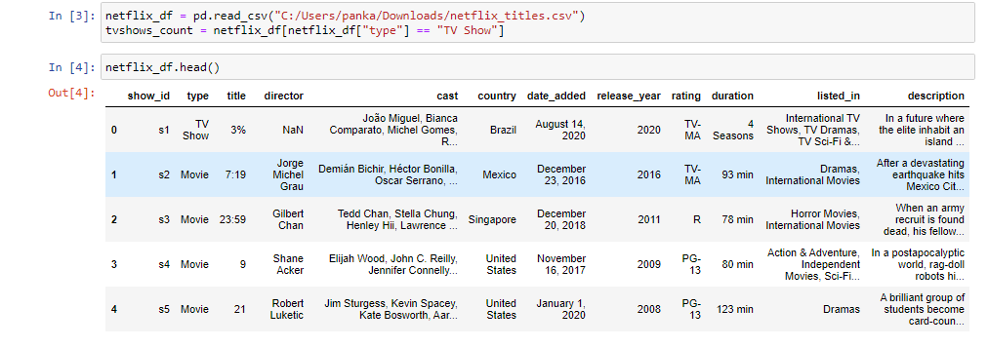

**4.3**

**Describe the model**

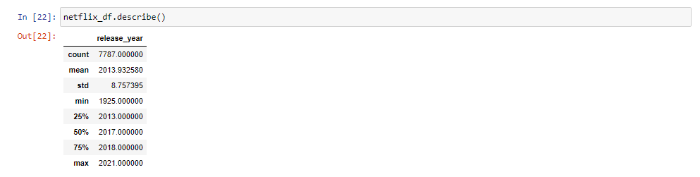

**4.4**

**Finding the missing values**

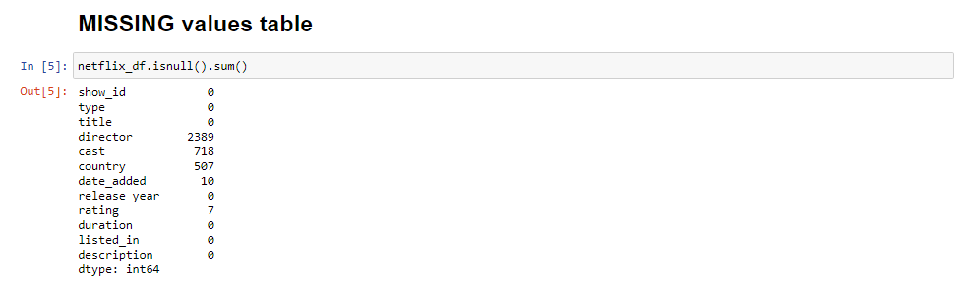

In the above data:

* I choose to drop the 'director' and 'cast' columns completely as they have high volume of missing values and dropping these columns will not affect my visualization.

**4.5**

# Comparison of TV Shows and Movies

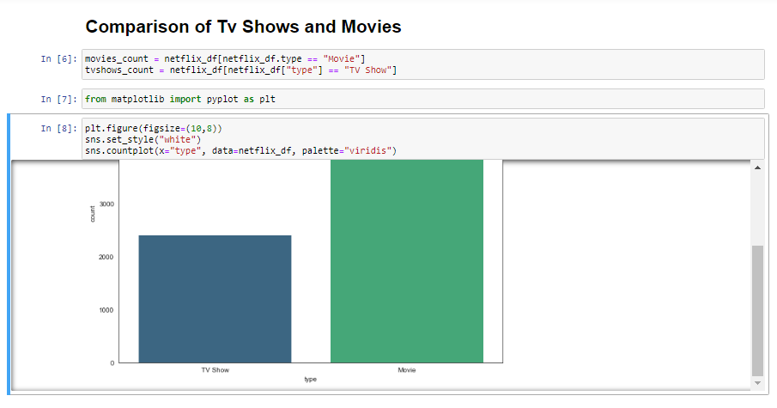

**4.6**

# Movies and TV Shows Content Comparison

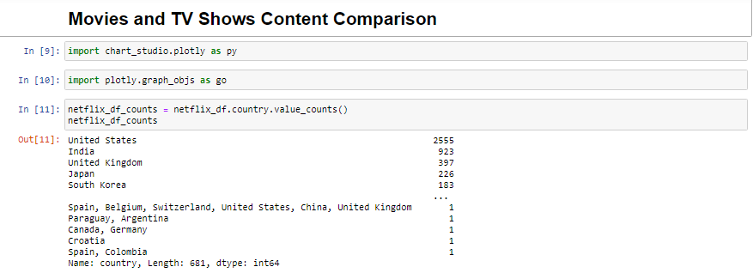

**4.7**

# Year wise content released visualization

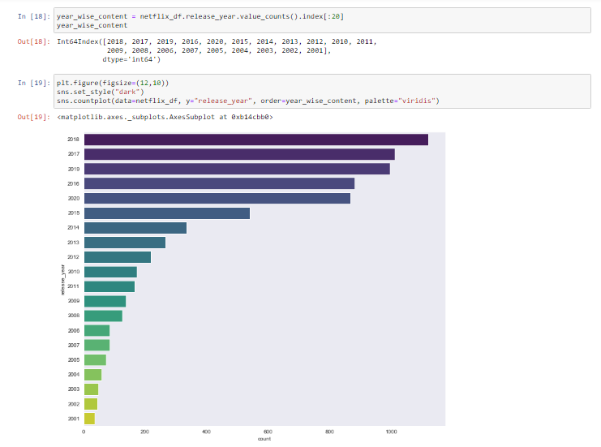

**5.**

**Tableau and Power BI dashboard**

**Data Visualizaton on Tableau**

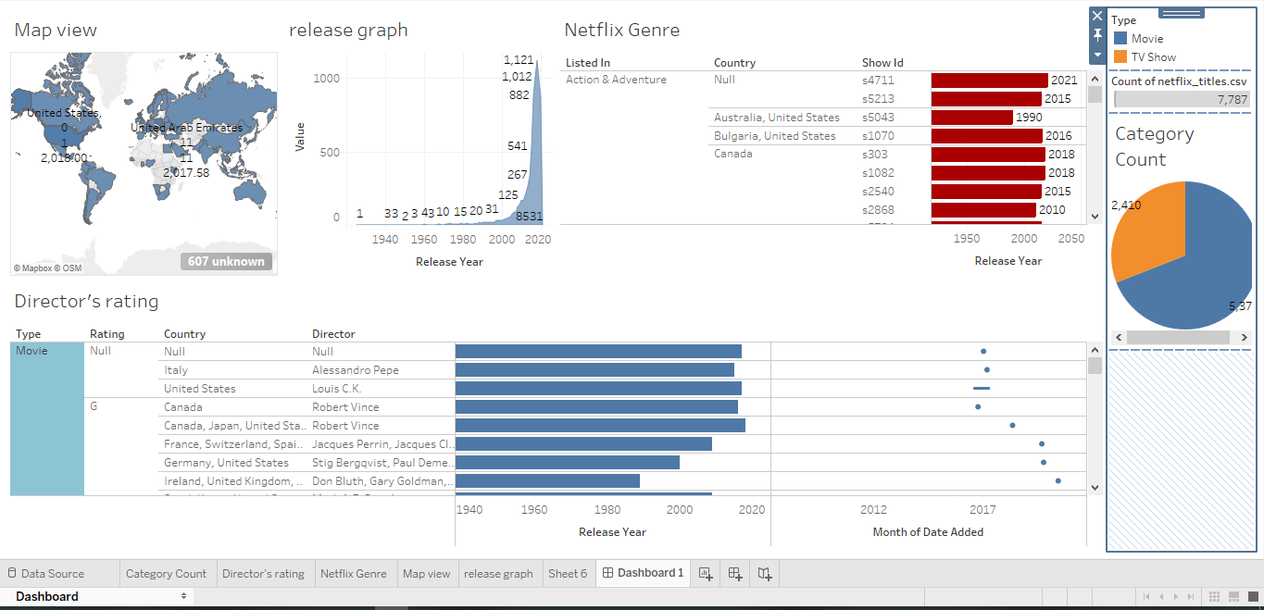

**Data Visualizaton on Power BI**

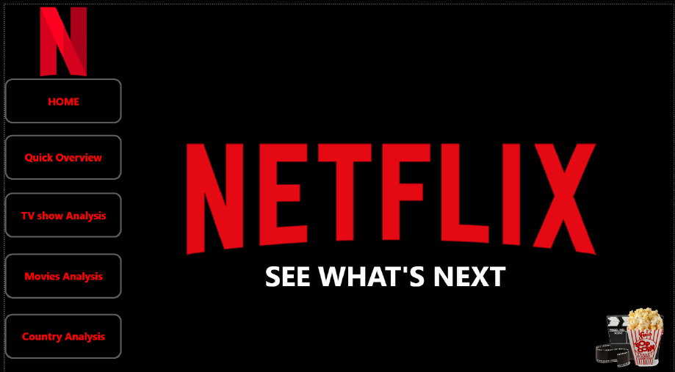

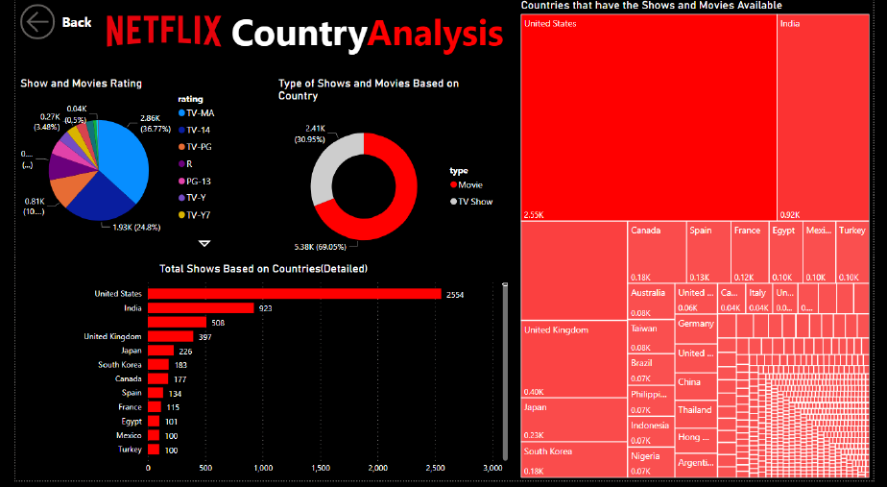

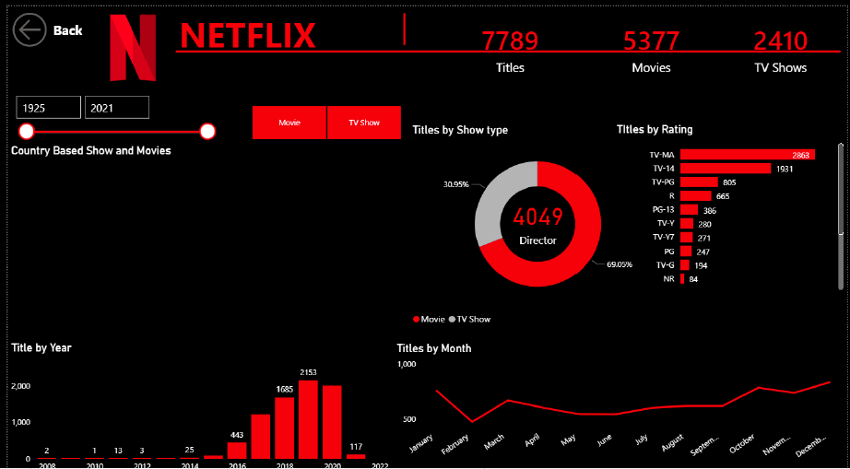

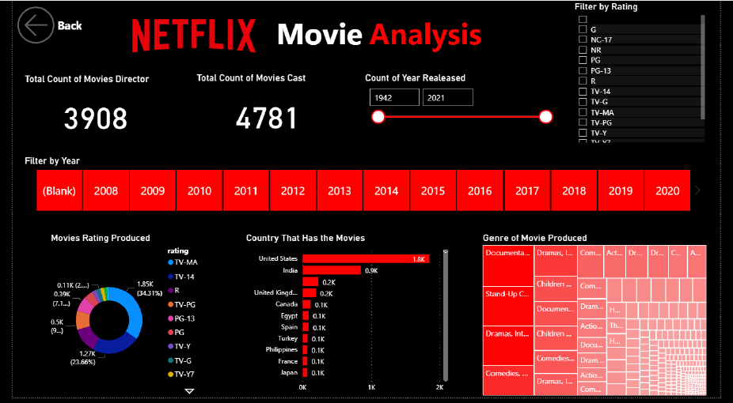

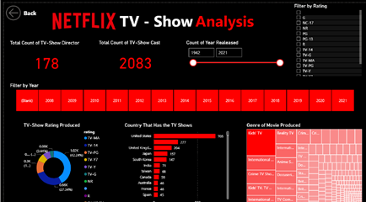

**6.**

**Future Scope And Conclusion**

**Future Scope**

Few Recommendation,

* Netflix to continue its use on Data analytics and Data Science to improve the customer experience.
* It is recommended to reduce the subscription cost as similar as its competitor for developing countries like India.
* Use of limited Advertisements to compensate loss of revenue due to lower subscription prices.
* Explore other territories for expansion.
* Produce more original content region specific.
* Tie Ups with different production studios to increase the content library.

**Conclusion**

In this paper we have discussed regarding business model of Netflix comparing it with the business

model of Blockbuster Inc. and how Netflix was able to beat its competitor to become leading online

streaming service provider. We discussed about the Netflix prize competition and how the winning

team algorithm made the existing algorithm of Netflix more accurate. We have also discussed about

the different kinds of recommendation system like content based and collaborative filtering recommendation system and use of Hybrid recommendation technique by Netflix. Also, we have

analyzed how with Big data Analytics is used for its recommendation system to improve the customer experience. We have also discussed how Netflix with the help of big data analytics can predict the viewing habits of subscriber and how it helped in producing the original content which would be a huge success